

**Final Report**

Submitted in partial fulfillment of the requirements for

ENGS 90: Engineering Design Methodology and Project Completion

**Vertical-Takeoff, Vertical-Landing Model Rocket**

*Sponsored by*

**Randy Witwick, *STEM Robotix***

**7.390**

Abby Ritterband, Ben Wolsieffer, Ethan Smith, Kenan Akin, Kevin Ponce, Michael Fraunberger

March 6, 2020

*Faculty Advisors*

Laura Ray and Minh Phan



**Executive Summary**

**Significance:** In late 2015, SpaceX and Blue Origin both announced successful landings of their reusable Vertical Take-off Vertical Landing (VTVL) rockets, furthering public interest in space exploration.Model rockets have connected students and hobbyists to the cutting edge of aerospace engineering since the early days of the space race, inspiring individuals to pursue STEM disciplines. **However, current model rockets are not capable of emulating full-scale reusable rockets. Specifically, there are no hobby-scale physical mechanisms, electrical software, or control designs sophisticated enough to facilitate a vertical landing. This disparity is preventing students and enthusiasts from engaging in and appreciating the new heights of rocket science.** A VTVL system for model rockets would greatly influence the next generation of scientists, engineers, and physicists, ensuring that their explorations of science and technology are not limited to the technology of the past.

**Objectives:** The objective for this project is to combine electrical and mechanical components to accomplish the goal of VTVL. This system must detect launch and apogee. It must then initiate a control system that will actuate the mechanical mechanisms of the rocket in order to slow its descent and remain upright through impact with the ground without sustaining critical damage. This system must be safe and reliable. It must be affordable and adaptable to the needs of multiple audiences, including hobbyists and students.

**Innovation:** No one has successfully created a VTVL model rocket system despite various attempts. These failures are due to overly-complicated mechanisms, unreliable propulsion systems, high cost, and time constraints. Our approach to the solution is simple: emulate the motions of full-scale VTVL systems using commercially available hobby products. Our solution will integrate hobby components with custom 3D printed systems (landing legs, electronics housing and fairing) in a unique model rocket architecture. In addition, it will adapt existing open-source software to the specifications of this problem. The final product will be accessible, affordable, adaptable, safe, and marketable.

**Detailed Approach and Methodology:** To achieve VTVL, we broke down our problem into four flight stages: the launch, apogee, descent, and landing. Each stage possesses its own requirements for the system to work, thus subsystems were established for each stage. The team worked together to design each subsystem and integrate them to create a final product. Both the mechanical and electrical portions of the system were designed through a process of research, careful design, meticulous testing, feedback and iteration.

**Impact:** By creating a VTVL model rocket, we will greatly change the current landscape in model rocketry by advancing the capabilities of model rockets towards those of full-scale modern rockets. Currently, only expert hobbyists with extensive time and resources can dabble in this area of model rocketry, but by making our rocket commercially available, we will give access to students and less experienced enthusiasts as well. This innovation will inspire future generations to continue pushing the boundaries of existing technologies.

**Table of Contents**

**Problem Statement and Significance** **5**

**Project Goals** **5**

**Solution and Innovation** **6**

**Approach and Methodology** **7**

Control Electronics 7

Thrust 7

Launch Mechanisms 8

Inherent Stability 9

Attitude Control 10

Vehicle Transition System 11

Landing Logic 12

Landing Mechanism 13

Vehicle Integration 14

**Goals Revisited** **15**

**Consultants and Supporting Staff** **15**

**Sponsoring Company** **15**

**Intellectual Property** **15**

**Product/Implementation Plan** **16**

Market, Customer, Competition 16

Economic Analysis 16

**Next Steps and Future Work** **18**

**Conclusion** **18**

**Appendix A: Supplementary Materials & Bill of Materials**

**Appendix B: Testing Description and Results**

**Appendix C: CAD Sheets**

# 

# Problem Statement and Significance

In recent years, companies in the private space industry, including SpaceX and Blue Origin, have pushed the boundaries of rocket technology through the creation of reliable and reusable vertical takeoff vertical landing (VTVL) rocket systems (Grush, 2015). These VTVL rockets are the first step toward the creation of a fully reusable rocket, a concept previously deemed impracticable before the emergence of these private companies in the space industry.

These advancements are undeniably exciting. VTVL systems have captivated the attention and curiosity of the public, especially model rocket enthusiasts. The development of a VTVL model rocket system would give these model rocket enthusiasts access to a hands-on learning experience that mimics modern day rocket technology. However, state of the art model rockets lag behind contemporary rocket capability. Model rocket technology currently lacks electrical, software, hardware, and control design sophisticated enough to emulate full-sized VTVL rocket systems, preventing hobbyists and students from partaking in and learning from the new heights of rocket science.

# Project Goals

The primary objective of this project was to develop a model rocket that is capable of taking off vertically using traditional solid rocket motors and performing a controlled vertical landing using an electric ducted fan (EDF). To achieve a controlled landing, the project had to develop a number of compatible systems that each perform a specific task. The first undertaking of the project was to determine exactly what is required for a solution to be viable. The solution needed to produce thrust that could be controlled to achieve a desired descent velocity. Another system needed to reliably control rocket attitude on the pitch, roll, and yaw axes as depicted in Figure 1. These control systems had to be developed in parallel with the physical mechanisms required for transitioning from the launch configuration to the landing configuration.

The technical requirements developed for the solution are summarized in Table 1. There were many intermediate steps in reaching these goals, but Table 1 presents the final specifications that define whether a solution is viable. Making adequate progress toward each of these requirements is necessary for the project’s success.

**Table 1.** Technical requirements for the design

|  |  |  |  |
| --- | --- | --- | --- |
| **System Coordination** | **Thrust Ratio** | **Launch Mechanisms** | **Inherent Stability** |
| System containing firmware responsible for managing all electronic components | Thrust to weight ratio greater than one such that the final velocity is tolerably small upon landing | Process and components for safe and reliable launch | The rocket must be aerodynamically stable such that it is statically stable in free fall |
| **Landing Mechanism** | **Attitude Control** | **Vehicle transition** | **Landing Logic** |
| A set of landing legs or similar system that can absorb the impact of landing | At low speeds the vehicle loses aerodynamic stability and must have the control logic and surfaces to right itself | The vehicle that launches must have little drag. The system that lands will have landing legs extended and a hole through the middle for an EDF. This transition must occur mid-air | A set of instructions embedded in the rocket system for managing landing sequence |

While Table 1 outlines the technical objectives required to create the solution to the stated problem, there were also goals and deliverables that specifically addressed the project sponsor’s needs. These are the following:

1. Develop flight control software for VTVL model rocket
2. Design an electronics and hardware package for VTVL model rocket
3. Three camera video documentation of flight sequence
4. Produce design files for all specific parts and electronics
5. Target bill of materials (BOM) under $100

Section 5 will revisit both the technical objectives and the sponsor’s deliverables.

# Solution and Innovation

The final prototype of this design comprises a combination of custom and commercial off-the-shelf parts, all of which were carefully selected to fit a specific purpose. A complete list of parts can be found in Appendix A.

The main components of the rocket are a 56mm rocket body tube that houses an EDF within the body of the rocket. The EDF requires an electronic speed controller (ESC) to control its output and a battery to power it. These components are fixed to the rocket body by an electronics chassis. The chassis also houses a servo motor to deploy the landing legs and a Bluetooth receiver for a wireless connection with the flight controller.

A servo collar serves as the attachment hub for four servo motors. These motors control the custom-made thrust vector control (TVC) vanes, which direct the EDF thrust to control the attitude of the rocket. Four spring-loaded landing legs are also fixed to the collar. Finally, a deployable fairing encapsulates all of the hardware during launch. At apogee, the fairing is ejected to allow the hardware to execute the landing stage. 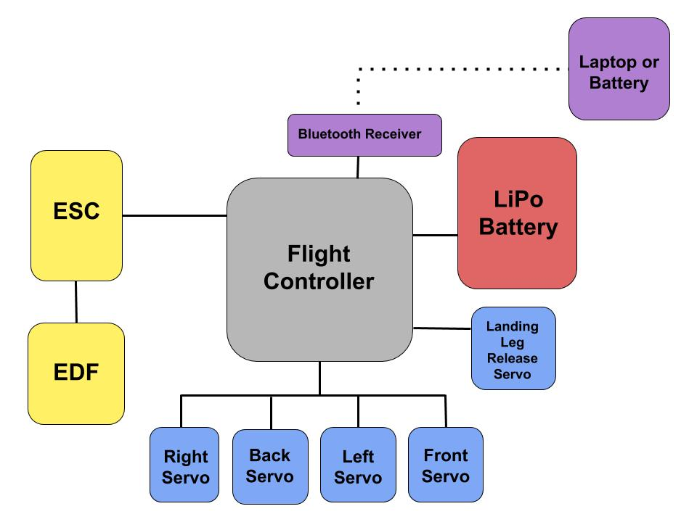

The flight controller commands all aspects of the system. It contains an inertial measurement unit (IMU) that outputs the orientation and acceleration data used in the flight code to make decisions during flight. This flight code is based on the open source ArduPilot firmware. The flight controller sends PWM signals to the ESC to control throttle, to the servo motors controlling the TVC vanes and to the servos controlling the deployable components. A high level electrical diagram for the rocket can be found in Figure 2.

A successful launch proceeds as follows (and as shown in the numbered steps in Figure 3). On the ground, the rocket is attached to its launch stage and affixed to the launch rail (1). The rocket motors and igniters are arranged as on a traditional model rocket. A fully charged battery is placed in the chassis and connected to the flight controller, which is preloaded with the correct flight mode and settings. 

Upon turning on and arming, the controller records its altitude and sets a ground reference. In future versions, the controller would conduct a series of system checks and send a checks-passed message via bluetooth to a nearby laptop or phone. The rocket is then ready to launch. When the igniters fire, the rocket lifts off (2) and the flight controller detects the acceleration. After the motors burn out, the three side boosters separate and fall away with streamers (3). 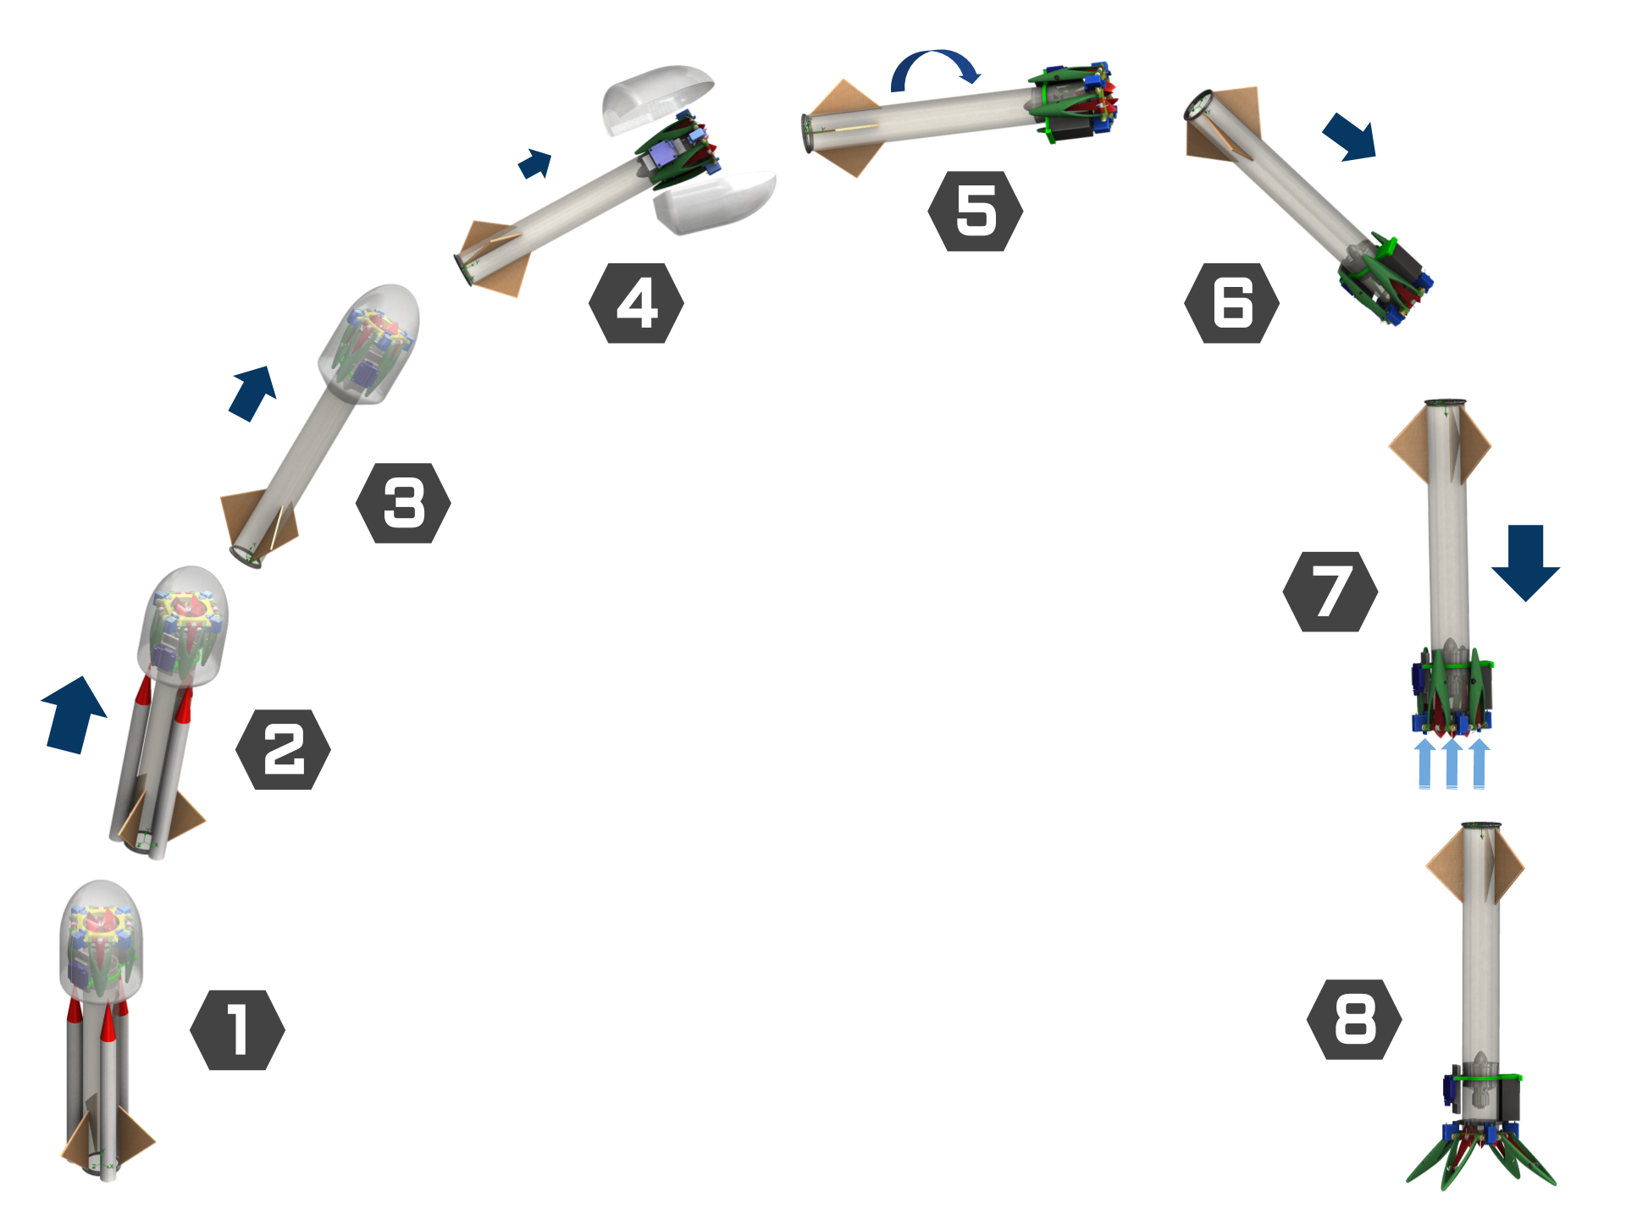

At apogee, the flight controller detects that its velocity is zero and activates the EDF to deploy the fairing (4). The fairing falls away, and acts as its own parachute due to its light weight and large surface area.

The rocket inverts and begins to descend (5). As the rocket descends, it eventually reaches a threshold velocity where it is passively stable and vertical (6), then it uses data collected by the IMU and barometer about its attitude and velocity to adjust EDF thrust and the TVC vanes (7). The system autonomously maintains a vertical orientation without the rocket spinning about its yaw axis, until the rocket is five meters above its ground setpoint. Once the rocket reaches this point, it deploys its landing legs and descends at a fixed velocity to the ground (8), where the EDF shuts off. 

# Approach and Methodology

This section will outline and describe how each of the requirements for a functioning system was achieved, describing the components and the testing used to verify if each requirement was satisfied. Descriptions of each named test along with the test results may be found in Appendix B.

## Control Electronics

All electrical components on the rocket are managed by an Airbot OMNIBUS F4 Pro V3 flight controller, which is intended for quadcopters. This controller was chosen for its small size and low cost. The flight controller contains an ARM STM32 microcontroller which runs a modified version of the open source ArduPilot firmware. It communicates with a ground station (laptop or phone) using a Bluetooth serial adapter and uses a Futaba RC receiver to allow control from an RC transmitter for testing purposes.

ArduPilot was used because it provides well tested sensor fusion and feedback control algorithms. It already supports “single copters”, a type of drone that uses a single motor and thrust vector control vanes for stability, similar to the rocket prototype. ArduPilot also provides ground station communication protocols and logging.

## Thrust

First, a 50mm EDF and a 56mm body tube were selected due to their close diameters which allow them to press fit into each other, making it the simplest, lightest, and most cost effective solution. This configuration was inherited from the original prototype provided by the sponsor. The selection of both the battery and fan are important to achieving sufficient thrust to land the rocket. Initially, a 3S (3 cells in series) lithium polymer (LiPo) battery was used. This did not produce enough thrust to lift the rocket. Switching to a higher voltage 4S battery increased the thrust. The EDF originally had a rounded inlet; this was removed to allow the fan to fit within the rocket tube. As an experiment, this inlet was attached to the top of the rocket tube and resulted in a large increase in thrust. A summary of these results is shown in Figure 4. The configuration of a 4S battery and rounded inlet was then used on all later prototype iterations.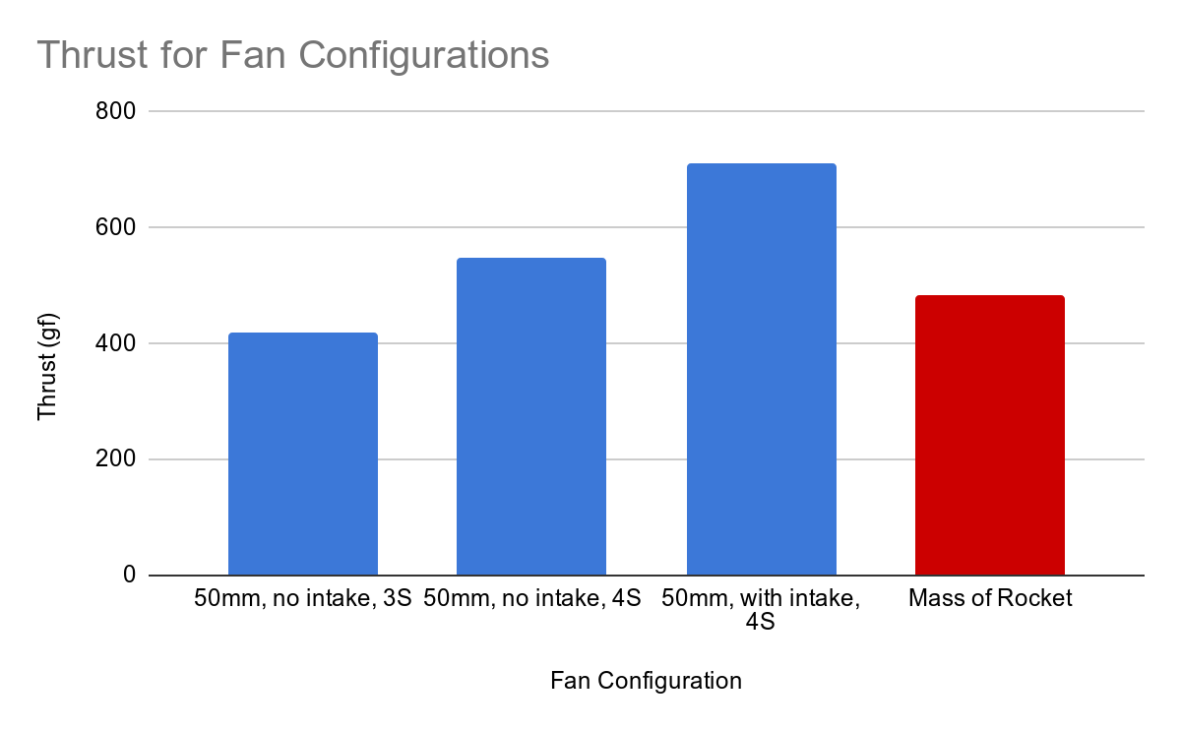

The capacity of the LiPo battery was chosen to safely sustain the current draw of the EDF. The available current scales with the battery capacity, and it was found that the smallest readily available battery that could provide enough current had a capacity of 850 mAh. This capacity provides about a minute of flight time at a hover. This is more capacity than is needed for a landing, and allowed the rocket to climb to altitude under its own power to test the landing sequence. The battery is the rocket’s heaviest component, and consequently shifts the center of mass of the rocket to a slightly unfavorable position off the center axis of the airframe, making control slightly more difficult. An attempt was made to use a pair of separate 2S batteries connected in series to balance the weight, but low cost batteries with the necessary current sourcing capability could not be found.

## Launch Mechanisms

The ascent stage of the rocket is powered by solid rocket motors that are widely used within the hobby community. The original ascent used commercially available “strap-on-booster-pods”, which can be seen in Figure 5. These pods attach to the side of the rocket tube and separate from the main body using an ejection charge with zero delay after motor burnout, and float to the ground using a streamer to provide drag. The maximum model rocket motor that these side boosters were able to accommodate was type C. However, after a launch using three class C motors at the end of fall term achieved an approximate apogee of 40m (half of the target 80m), the decision was made to scale the ascent motors up to class D motors. This doubled the total impulse of each motor from 10 N·s to 20 N·s. Increasing the total impulse ensured that the rocket would achieve the target height, and this was later confirmed in two ascent stage launches, where the rocket achieved a preferable 90m apogee in both tests. While the change was beneficial, scaling up the motors presented some design challenges.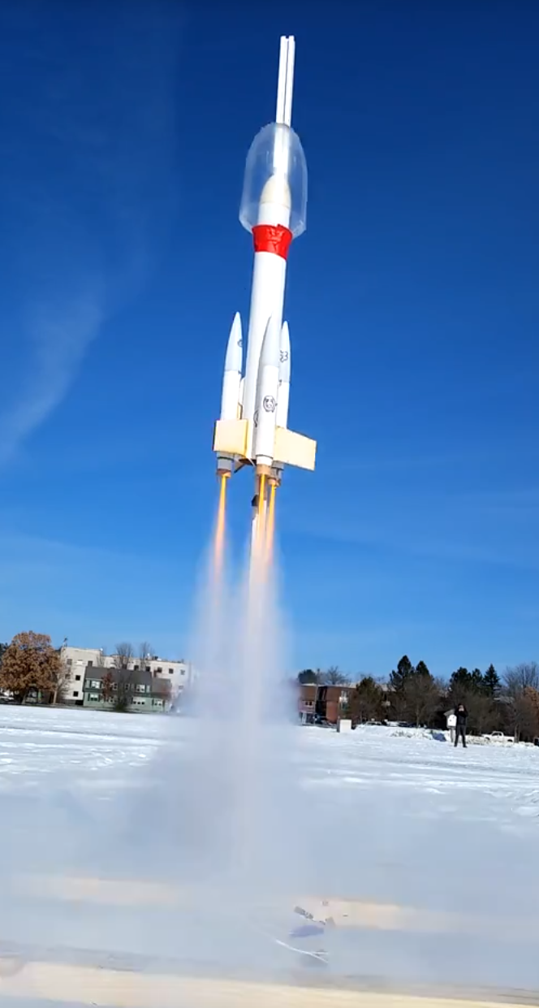

The first design challenge stemmed from the fact that class D motors have a larger radius than class C, which meant that they could not be used in the booster pods that are available commercially. This incompatibility was addressed with a custom version of the booster pod using a larger radius tube, shown in Figure 6. The pods were also reduced in length so they could accommodate the width of the fairing. New laser cut plywood pieces were designed to attach the smaller pods to the main body tube using the same plastic clips as the purchased pods. 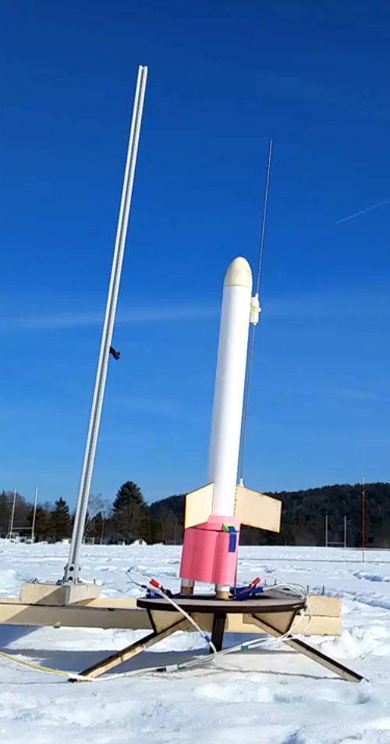

In addition to the pods, another ascent mechanism was developed that addressed concerns with the design of the pods. The first issue with the pods was the number of objects ejected and scattered around the field as it sometimes proved difficult to quickly find the three pods after a launch. A second issue occurred during the launch in the fall when one pod failed to separate from the main body. This could prove catastrophic for the dynamics of the rocket during the landing sequence. A “first stage” was developed that contained all three motors in a single 3D printed structure, shown in Figure 7. This first stage mated with a collar that attached to the rocket and also served to hold the fins in place during assembly. When the ejection charges fired inside the bottom section, the gas would push against the collar and separate the motors, which would fall back to the ground in one piece using a parachute.

Two rockets were created with a mass simulator in the approximate location of the landing gear’s center of mass to bring the test rocket’s weight to 600g and a fairing was placed on the nose. These rockets were used to test the first stage and side pods. In past launches, a launch lug was attached to the side of the rocket and slid along a steel rod to ensure a straight launch. However, the width of the fairing made this method impossible. Inspiration from high powered rocketry led to the solution: a 6-foot extrusion of 80/20 to serve as a vertical guide for two delrin launch rail buttons placed on standoffs that cleared the fairing. With these changes, the rocket reached an apogee of over 90m in both tests. The pods separated and worked as planned. The first stage experienced problems when the parachute chords tangled on the fins during ejection. It was determined that more tests were needed.

In these tests, issues were experienced with the simultaneous ignition of all three motors, called clustering, which proved to be an problem toward the end of the project. In addition to delaying tests of the first stage concept, the failed tests were costly to the development of the vehicle transition system described in Section 4.e. A commercially available launch controller powered by a 12V tractor battery that provided enough current to the igniters was chosen for the final launch. This worked, however there are still concerns about the future reliability of the ignition system. The next steps of this project should include further research on model rocket motor clustering techniques. 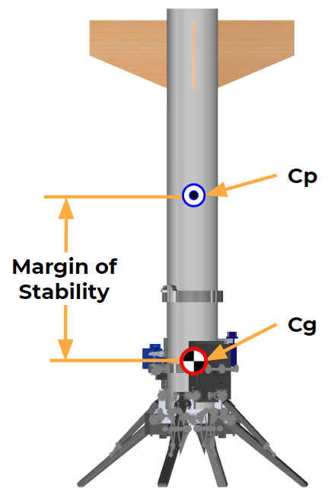

## Inherent Stability

The inherent aerodynamic stability of the rocket ensures that the vehicle has a smooth and controllable flight path. The margin of stability (MoS) is determined by the distance between the center of pressure and the center of gravity divided by the diameter of the body tube (Figure 8). Stability was achieved through the use of three radially spaced fins. To prevent excessive drag during ascent, which would decrease the apogee altitude and affect the attitude, a fairing was developed to encompass the electronics and landing hardware. The MoS for the first stage ascent vehicle and side pod vehicle are 1.08 and 2.94, respectively. Stability on the descent means added controllability. The MoS of the descent vehicle was 3.09. Each MoS was calculated using a SolidWorks flow simulation.

## Attitude Control

The attitude control system uses four standard 9 gram metal gear hobby servos that move TVC vanes to direct the thrust of an electric ducted fan. Tower Pro MG90S servos were chosen for their speed, durability, and minimal backlash. Different combinations of vane deflection torques to be produced around the roll, pitch and yaw axes. The vanes use an airfoil profile designed to maximize the amount of thrust vectoring, while minimizing the reduction in the thrust output of the EDF. The axis of rotation of the vanes has been placed below the end of the airframe. This placement allows the air to produce a maximum moment on the rocket body, instead of directing flow into the sidewalls of the airframe.

The thrust vanes are controlled with three independent PID control loops that each attempt to maintain a desired angular velocity around the pitch, roll and yaw axes. The desired angular rate is determined using a simple proportional controller that tries to maintain a vertical attitude.

The initial prototype provided by the sponsor used TVC vanes that were connected to servos using long linkages. It was quickly determined that such a configuration would introduce an unacceptable level of backlash into the system, so the servos were moved to directly connect with the vanes. Initial attitude control testing was performed in a two-axis gimbal. This test provided an easy and low risk way to observe the behavior of the attitude control system and validated the basic functionality of the vanes. The friction between gimbal components significantly changed the dynamics of the system, limiting the utility of this test for performing further tuning of the control system. The next stage of testing was performed in free flight, attempting to hover the rocket like a drone. Initially, a lightweight tether was used to catch the rocket when it lost control, but it had a tendency to get sucked into the fan or alter the dynamics of the system. The design of early tests was influenced by the desire to reduce the risk of damage to the rocket, but there was a point where further progress could only be made by accepting that the rocket would sometimes crash and be damaged. More hover tests were performed with no tether. A team member was prepared to catch the rocket if it lost control, but this safety measure was not always successful. The resulting breakages provided useful insight into the weak points of the landing legs and thrust vectoring hardware. This informed future iterations and led to an emphasis on easily replaceable parts. The control system gains were iteratively tuned, primarily by visual analysis of the rocket’s response to attitude commands and external disturbances. 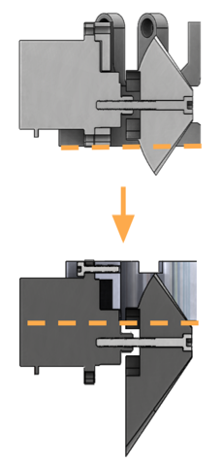

The guiding process for tuning was to increase the proportional gain until visible oscillations were observed, then decrease it slowly until the oscillations cease. Then the process was then repeated with the derivative gain. This guiding principle was recommended by the ArduPilot documentation. The initial iteration of the vanes could not exert enough force on the rocket to cause oscillations due to the proportional gain, instead the vanes would saturate. A value that did not cause vane saturation but still provided seemingly adequate gain was selected. This allowed the rocket to reliably remain vertical and recover from limited disturbances. In an attempt to correct certain cases of instability, gyroscopic precession correction was applied by applying a multiple of the roll and pitch torque to the perpendicular axis. This was found to have little to no effect on stability.

This milestone enabled testing of the descent sequence to begin (see Section 4.g for more detail). Unfortunately, the tests quickly showed that the attitude control system became unstable under more realistic descent conditions. Using hover tests once again, the derivative gain was increased to try to limit vane saturation by eliminating overshoot. This attempt was unsuccessful, and it was determined that mechanical changes were needed to increase the maximum torque that could be provided by the vanes.

As detailed previously, the original designs used linkages to connect the servos to the TVC vanes. To minimize backlash, the TVC vane collar was designed to directly integrate the servo motors. This allowed the vanes to be directly connected to the metal gear servos, which minimized the backlash in the vane actuation. The vanes were designed to have a full 180° actuation within the airframe, but hover testing revealed that full actuation was unnecessary to a stable rocket. Instead, the size of the vanes was increased, and the axis of the vanes was shifted outside of the airframe (Figure 9). This allowed the thrust vector to provide a cleaner torque about the rocket body. The increased vane area directed more airflow in the proper direction, and that thrust was prevented from hitting the sides of the airframe. These changes provided much more controllability. Using the new vanes, the rocket was tuned using the ArduPilot guidelines. The resulting configuration yielded greatly improved disturbance rejection and control. Before this change, hover tests were short and the rocket was extremely sensitive; after this change, hover tests could take place for as long as the LiPo battery allowed. The rocket could be commanded to fly in any direction more easily, and recovered from disturbances without crashing. The hover testing that took place after this development yielded the final control gains for this solution. 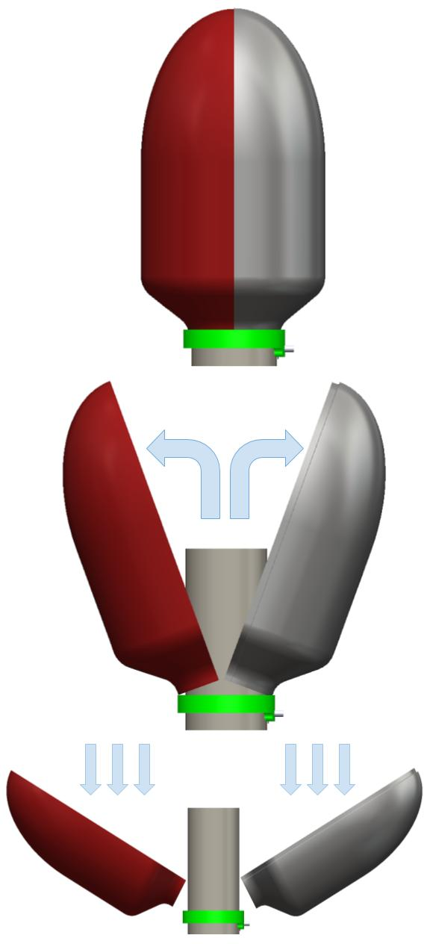

## Vehicle Transition System

The term “vehicle transition” refers to the physical mechanisms that transform the rocket from its aerodynamic launch form to its controlled descent form. This is achieved through the deployment of the fairing and the release of the landing legs. The fairing comprises a clamshell design that covers the electronics and landing hardware during the ascent and is released at apogee to transition the vehicle to its descent configuration. It comprises two halves which fit together using an inner lip on one side over which the other half fits. The halves are manufactured by thermoforming plastic using two seperate molds. The original design used tensioned rubber bands to hold the fairing in place during launch and then released the halves by severing the bands with a heated NiChrome wire. Tests of the NiChrome wire circuit revealed that the required power was difficult to manage with the flight controller and when the circuit did function, it was too slow to come up to temperature in the context of the short flight. The hold and release mechanism was reworked and the final design uses a small magnet at the top of the fairing which can be separated with the thrust of the EDF (Figure 10). 

The landing legs were initially designed to have a hold and release mechanism similar to the fairing - a rubber band released with a heated NiChrome wire. Once the NiChrome wire idea was put aside, a new system was designed to release the legs. A rubber band still wraps around the folded legs to secure them against the airframe, but a new servo-actuated pin release was added. The servo actuates and releases the pin to free the legs (Figure 11).

Both systems were thoroughly bench tested, however, due to issues with the cluster ignition described in Section 4.b, several tests of these systems in real launch conditions were unable to be performed. This proved to be problematic during the final launch, and an improvised vehicle transition system that failed to properly deploy at apogee was used. Had the fairing released at apogee, the chance of a successful launch and landing would have been significantly higher. Perfecting this system remains a crucial next step in the project.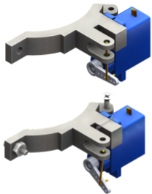

## Landing Logic

The flight controller firmware has a custom VTVL flight mode for the landing. The flight mode implements a state machine that detects the launch, apogee and other events and performs the necessary actions in each state. The basic logic was validated in ArduPilot’s software in the loop simulator, which was modified to simulate a simple rocket launch. The first attempt to test the landing in the real world was performed by lifting the rocket with helium balloons. The rocket would be dropped from the balloons and then attempt to perform a controlled landing. Wind prevented the balloon from achieving the necessary altitude, and the logistical issues with managing balloons prevented the test from being performed again. A much simpler alternative test was designed, which involved flying the rocket up to altitude under its own power and then beginning the descent. This allowed many tests to be performed under a variety of conditions and the results informed changes in the landing sequence, which are described here.

After apogee, the EDF first runs for a short period of time to eject the fairing. The rocket continues in freefall until it passes a velocity threshold. Initially, the velocity threshold was set to 1 m/s, which resulted in the fan starting almost immediately after apogee, while the rocket was in a non-vertical orientation. When the rocket is far from vertical, the active attitude control system is unable to recover and causes the rocket to enter an uncontrolled high amplitude oscillation. One attempted solution to this problem was scaling down control vane torque with vertical velocity. It was assumed that reducing control vane torque at high velocities would allow the aerodynamic forces to stabilize the rocket and eliminate control system induced oscillations. Unfortunately, testing showed that even with no thrust vectoring, the fan thrust introduced disturbances that destabilized the rocket even at high velocities. This led to the conclusion that the rocket must be allowed to build up speed in freefall to allow it stabilize without any disturbances due to the fan or control vanes. The velocity threshold was increased to 6 m/s, which resulted in a successful test landing, but was not reliable. Increasing the velocity threshold further would make it more difficult for the rocket to slow itself before it hit the ground, so it was decided to add fins to the rocket body. Previously, the fins were going to be ejected as part of the side pods or first stage. This change allowed the velocity threshold to be reduced to 5 m/s and made the descent 100% reliable during test flights. This gives time for the rocket to rotate to a stable nearly vertical attitude due to aerodynamic forces. More details on this testing can be found in Appendix B.

Once the velocity threshold is passed and the fan is started, the rocket will modulate the throttle to maintain a constant deceleration towards a target final velocity of 1 m/s at an altitude of 5 meters. At the same time, the attitude controller adjusts the control vanes to keep the rocket upright.

Below 5 meters, the rocket maintains a constant vertical velocity of 1 m/s, and then slows to 0.5 m/s at 2 meters. The constant velocity portion of the descent allows the rocket to handle errors in its altitude estimate or changes in the ground level relative to the launch site. The detection of touchdown is not done based on altitude, but by observing that a reduction in throttle does not cause the rocket to descend further.

## Landing Mechanism

The vehicle achieves a stable touchdown at the end of the descent stage using deployable landing legs connected to the landing leg/TVC vane collar. On deployment, the legs rotate outwards due to tensioned rubber bands on the struts. The leg system contains a strut that locks the legs into place and prevents them from folding upon touchdown. The legs are stiff enough to minimize deflection upon landing, and tough enough to withstand the impact. A modular construction of the landing legs was chosen to provide flexibility and rapid repairability. Small assemblies contain the pin mounts for the legs and struts as seen in Figure 12. These assemblies then screw into the landing leg collar that is attached to the airframe. In a non-optimal loading condition, such as the rocket landing on its side, the pin mounts serve as breakaway zones. The pin mount can be quickly replaced without drastic repairs to the main rocket airframe itself.

Initial designs used torsional springs to create a suspension system, without incorporating a locking mechanism, but through deflection calculations it was found that the spring force would not be sufficient to withstand the impact load, and could damage the TVC vanes. Rubber bands were explored as an option, but it was found that the spring coefficient necessary to prevent deflection could not be achieved. Taking inspiration from other model rocket landing legs (Rocketry Forum 2019), the locking strut leg mechanism was designed (Figure 13). These provided the stiffness necessary to prevent hitting fragile components, such as the vanes, on touchdown. These legs work well under the proper final descent stage sequence, when the rocket descends at a low final velocity around 0.1 m/s.

There were also issues with landing leg and servo collar parts breaking easily in non-ideal loading conditions during testing. This was addressed by switching materials from the Objet SLA resin to Polylactic Acid (PLA) plastic material. This material provided enhanced stiffness and toughness. In addition, increasing the 3D printer infill density and wall thickness improved the strength. Subsequently, there were significantly fewer leg breakages. The legs were able to withstand freefall drops from above 1 meter without failure. The landing leg assembly was tested using an Instron materials testing machine, where the legs withstood over 450 Newtons of force. The test configuration and load data can be found in the Appendix.

It was necessary to facilitate rapid testing due to the constrained timeline, by designing the system to be strategically modular. The landing leg/TVC vane collar mounts to the airframe using hex bolts, instead of glue, to allow easy replacement of collars and airframe tubes. The servo motors slip easily in and out of the landing leg collar without removal of the vanes, and they secure to the collar using one servo mount screw. The landing legs comprise a single subsystem, which is then fixed to the collar and airframe with the same bolt (Figure 12). These design decisions mean that all subsystems are replaceable at the point-of-test. As well, this allowed the pin mounts to have increased strength by printing in a concentric path around the pin mount holes, preventing shear failures between layers. The printing configuration can be found in the Appendix. In optimal loading conditions, these parts have high ultimate strength. In non-optimal conditions (such as a lateral load or the rocket landing on its side) the pin mounts act as breakaway zones (Figure 13), and are easily fabricated and replaced. 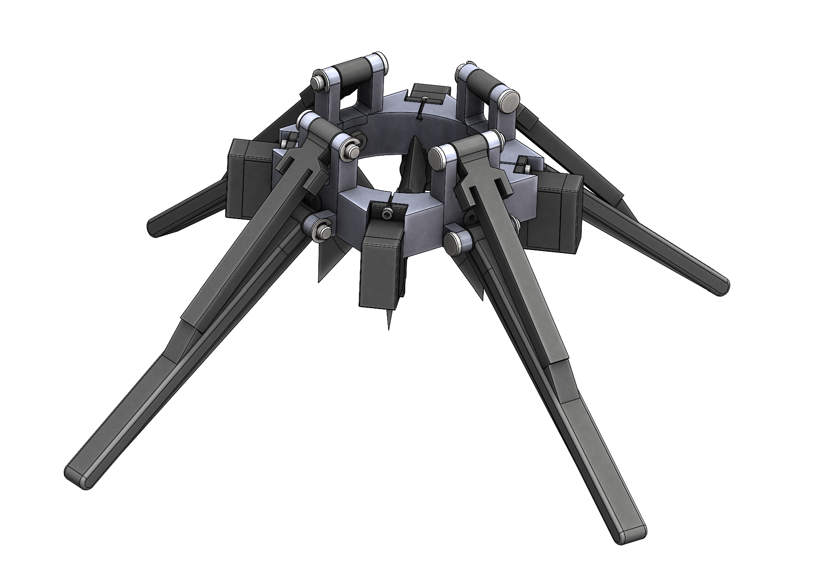

## Vehicle Integration

The final system required for a successful VTVL model rocket launch is the integration of the various subsystems and components. By the end of the project, one fully integrated prototype vehicle was built and launched, and is shown in Figure 14 (before fins were added to the aft). It comprised the subsystems as described in the previous sections, with one notable exception: the vehicle transition system. Due to a lack of testing of the transition system, two major decisions were made: one was to replace the fairing with a slip-on design, the other was to deploy the legs with the release of the fairing. The decision to use a slip-on fairing was motivated by fitment issues of the clamshell with the electronics package and redesigned TVC/Landing Leg system, as well as bench tests that indicated the viability of blowing the slip-on fairing off at apogee. The deployment of the landing legs and the fairing were combined to reduce the number of possible failure points during a launch.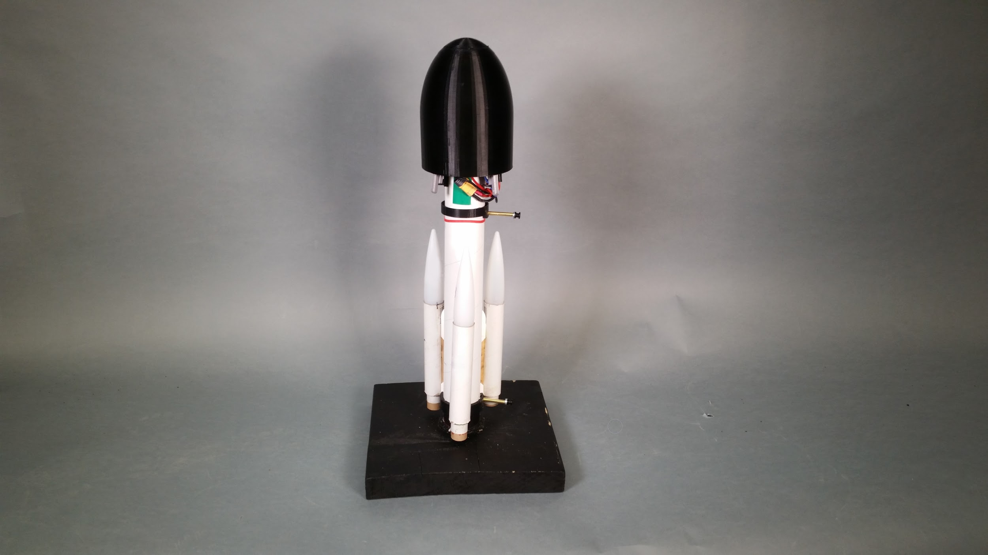

Although the landing of this vehicle was ultimately unsuccessful, it revealed two areas that required improvement: the fairing deployment mechanism and the timing of release of the fairing. During launch it appears that the aerodynamic pressure kept the slip-on fairing pressed onto the rocket longer than desired. A software issue that was hidden during testing also caused the EDF to start about 0.5 seconds later than intended. These issues caused the rocket to build up more speed than intended, leaving too little time to stop the rocket before impact.

Future work on the VTVL model rocket should investigate the clamshell fairing, as the two halves of the clamshell use aerodynamic forces on the rocket to finish full separation once they are initially split apart, leading to more reliable full deployments. The team determined after this launch that modifications could be made to the packaging of wiring and the landing leg length to result in a workable fairing using the current clamshell design.

# Goals Revisited

A description of the technical goals is found in Section 3. The thrust ratio, inherent stability, landing mechanism, and attitude control can be considered to be well developed. While the systems that achieve these goals are not in their final iterations, it can be confidently stated that these goals have been achieved at this juncture. The launch sequence, vehicle transition, and landing logic, are areas for further development.

Progress was also made on the sponsor goals. Software, electrical, and hardware packages have been developed to contribute to the technical progress described above. Since more must be done to achieve the technical objectives in full, these packages are subject to change in future work. However, all hardware and software associated with the current solution are organized and available for the sponsor’s continued use and development. The goal to acquire three-camera (ground, air, and onboard) documentation of the flight was achieved during the full vehicle launch. The target bill of materials goal is partially achieved and similarly subject to change. The bill of materials is expanded upon in Section 9. Prints and assembly documents, located in Appendix C in part, were made for all custom parts and mechanical subsystems.

# Consultants and Supporting Staff

The advisors to the project were Professor Minh Phan and Professor Laura Ray. Professor Phan’s research is focused on system identification and model predictive control. He was an excellent advisor for a project focused on controlling the state of a rocket during its descent. Laura Ray’s extensive background in mechatronics and controls allowed her to provide excellent insight into the project as well. Raina White, a systems and fluids lab instructor, provided assistance with the small-scale wind tunnel in the fluids lab. Ther directors provided swift guidance when small problems threatened to hold up the project. Kevin, Scott and Miles provided assistance with rapid prototyping, and Bob Barry provided assistance with the control system.

# Sponsoring Company

STEM Robotix was founded by Randy Witwick when he noticed a demand from both parents and young students around the Upper Valley for after-school programs that taught the basics of robotics. The classes run by Randy closely align with FIRST Robotics and FIRST Lego League competitions, and this business grew out of his experience coaching FIRST teams. He currently runs classes for students in 3rd grade through high school, who start with little to no experience designing or programming robots. Randy is the only employee and he currently offers several courses throughout the year in addition to his work consulting as a PE.

The VTVL project started when Randy noticed that there truly was no commercially available model rocket capable of VTVL and he recognized a potential market that served both hobby model rocket enthusiasts and STEM educators. The vision to market the final design as a kit for both hobbyists and STEM educators is perfectly in line with the mission of STEM Robotix.

# Intellectual Property

The sponsor, STEM Robotix will retain all IP rights to license and sell the VTVL technology to other companies. This project builds on top of ArduPilot, which is licensed under the GNU General Public License, version 3 (GPLv3), which creates a legal obligation to both release the source code of any modifications made to the project as well as provide users with the ability to modify the software running on their rocket. However, any novel technologies that the group develops are theirs to patent if they so desire, such as a subsystem component or control software. STEM Robotix will be included in the patent if they have aided in the development process.

# Product/Implementation Plan

## Market, Customer, Competition

A commercially available VTVL model rocket does not exist currently. State of the art model rockets sold by large companies such as Estes Rockets or Apogee Components use a parachute to control their landing; thus, the product will be presented as a more capable alternative. It is likely that strategic planning and partnerships would need to be established with large model rocket distributors in order to promote the product.

When looking at other potential VTVL competitors, only BPS.Space stands out. This company has recently commenced a project that uses an EDF and TVC Vanes to hover a “hopper” (Barnard, n.d.). However, this device forgoes any actual solid rocket motor launch, and it is unclear whether Barnard plans to bring the final system to market.

The sponsor and team envision two main market segments for this product, model rocket enthusiasts and STEM education classrooms. Enthusiasts will likely be attracted to this product for its ability to reliably achieve VTVL and the fact that they can modify the product to meet any specification they see fit. At the same time, this product would be an excellent learning tool in middle school, high school, and college math and science classrooms.

## 

## Economic Analysis

With the sponsor’s end goal of bringing a VTVL model rocket to market in mind, the following section is an economic overview of a potential business that sells the VTVL rocket described in this paper. The final product would be delivered as a kit to be licensed to current model rocket component distributors. In order to appeal to not only model rocket enthusiasts but also novice users new to model rocketry, two separate versions of the kit will be available for purchase. The “Level 1” kit will be a complete kit, containing every component necessary to build an operational VTVL rocket. A full list of included components is located in Appendix A.

The “Level 2” kit will be marketed towards the experienced hobbyist who is well versed in model rockets and has the equipment and knowledge base to build them. The aim for this kit is to provide users with a foundation to create a VTVL model rocket, while still allowing them to have creative freedom in their design. The kit will include the flight computer, EDF, servos and batteries, but will leave the design of the ascent stage to the discretion of the user. The Level 2 kit will also include the CAD files necessary to 3D print the novel components so the user can utilize a maker-space available to them, whether they have a personal setup or can utilize a public library.

Individual components, such as the landing legs, TVC vanes, fairing, chassis, and collar will be available for purchase in the event of part failures and lack of means of fabrication. To assist in the creation of the rocket, both kits will include thorough, step by step instructions to help guide the user.

While there is potential for this product to be a profitable venture, suppliers need to be identified for components including the EDF, ESC, flight controller, 4S LiPo battery, and servo motors. These components can be obtained from standard suppliers, such as Apogee Rockets, Amazon, and Alibaba. Based on market research, initial estimates show the Level 1 kit containing every component of the rocket will cost around $120. While this is not under the cost of the original bill of materials (BOM) goal of $100, this estimate is intended to be conservative and is meant to represent the cost of the rocket in its most expensive configuration. The cost could be brought down significantly by purchasing bulk quantities from the part supplier listed above.

When creating these kits, the employee(s) of STEM Robotix would be responsible for programming the flight controllers, manufacturing the various 3D printed parts for the Level 1 kit, packaging all components, and shipping the kits. The 3D printed parts are made from lightweight plastic. Components such as the landing legs and TVC vanes can easily be produced in maker spaces since the same method was used for the prototyping of this project. As the business scales up, the company can look into injection molding these components. While the cost up front is expensive, injection molding is a more efficient way to produce these components and can be outsourced to companies such as Protolabs.

A financial viability analysis was performed to estimate the feasibility of bringing the VTVL rocket to market. This analysis assumes a single employee operates in a small office space, which is plenty of space to manufacture the small components in the kit. Assuming a BOM of $125 for the Level 1 kit and a BOM of $65 for the Level 2 kit, fair prices for these kits would be $170 and $120, respectively. Both kits are in line with the cost of current high-end model rocketry kits.

To begin producing these kits for market, it was estimated that a $25,000 business loan would suffice, assuming a 3 year payment period with 7% interest. To generate realistic sales expectations, it was assumed that only 25 kits would be sold within the 1st quarter and steadily increased to over 200 kits sold by the 8th quarter. Along with this, an assumption was used that more sales of the Level 2 kit compared to the Level 1 kit in the 1st quarter as it is likely hobbyists will be more likely to know about and purchase the product than more inexperienced users when first coming to market. As time goes on, and the product becomes a staple in model rocketry, it is assumed that the number of units sold for both kits should be about equal per quarter. The model predicts the products will be profitable by the 7th quarter as shown in Figure 15 below. Within three years this product could realistically net around $20k per quarter, and with possible partnerships with school districts, the VTVL rocket kit is likely to generate stable profits.

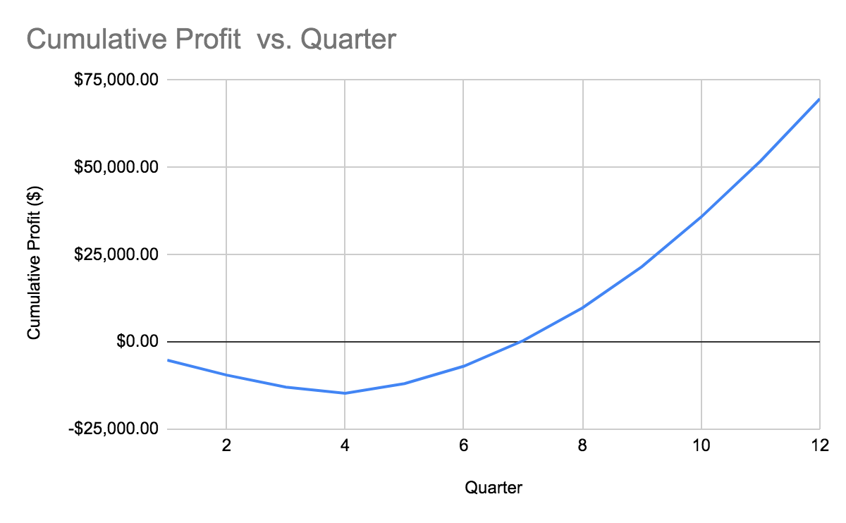

**Figure 15:** Plot of Cumulative Profit vs. Quarter

# Next Steps and Future Work

Were this project to continue, the most immediate barriers to a successful landing should be addressed. At the conclusion of this project, the most apparent barrier to VTVL is insufficient development and testing of the fairing deployment mechanism. In the single test launch, the fairing failed to deploy on time, and this was the most likely cause of the crash, although there were other factors at play. Perfecting this aspect of the design will allow further progress. The team believes that the magnetic clamshell design is the best path forward in this respect. However, the possibility of using nichrome wire to burn a rubber band and deploy the fairing is an additional avenue to be pursued. In addition to fairing deployment development, any continuation of the project should quickly determine a comprehensive testing plan, and most importantly ensure that they have the ability to complete those tests. In particular, the team should make sure that they have a reliable method for igniting their clustered motors to commence flight.

These two items are the most important for achieving VTVL. There are additional items that the team anticipates could be important. One of these is the likelihood that the rocket would tip over after an otherwise successful landing. This is often caused by the horizontal velocity the rocket might exhibit during flight. As the rocket touches down, one side of the landing legs may make contact before the other, and consequently act as a hinge over which the rocket will tumble. This issue could be solved by redesigning the center of mass below the landing leg connection points, or by finding a way to eliminate this horizontal motion during flight. The former would be an easier work around, but may not be highly effective. The control software could combine GPS and accelerometer data to minimize horizontal drift at landing, but would require significant effort. Once the system can reliably land vertically, the system should focus on producing and selling a viable market product.

# Conclusion

This project, while it did not achieve vertical landing from a launch, de-risked many of the barriers to the goal of VTVL. The EDF configuration has enough thrust to slow the descent of the rocket, the TVC vanes have enough control to maintain the rocket’s attitude, the landing legs can withstand impact at touchdown, and the software can manage each of these components so that they act as designed. There are areas that need more development. However, there is considerable reason for optimism for the eventual success of this solution.

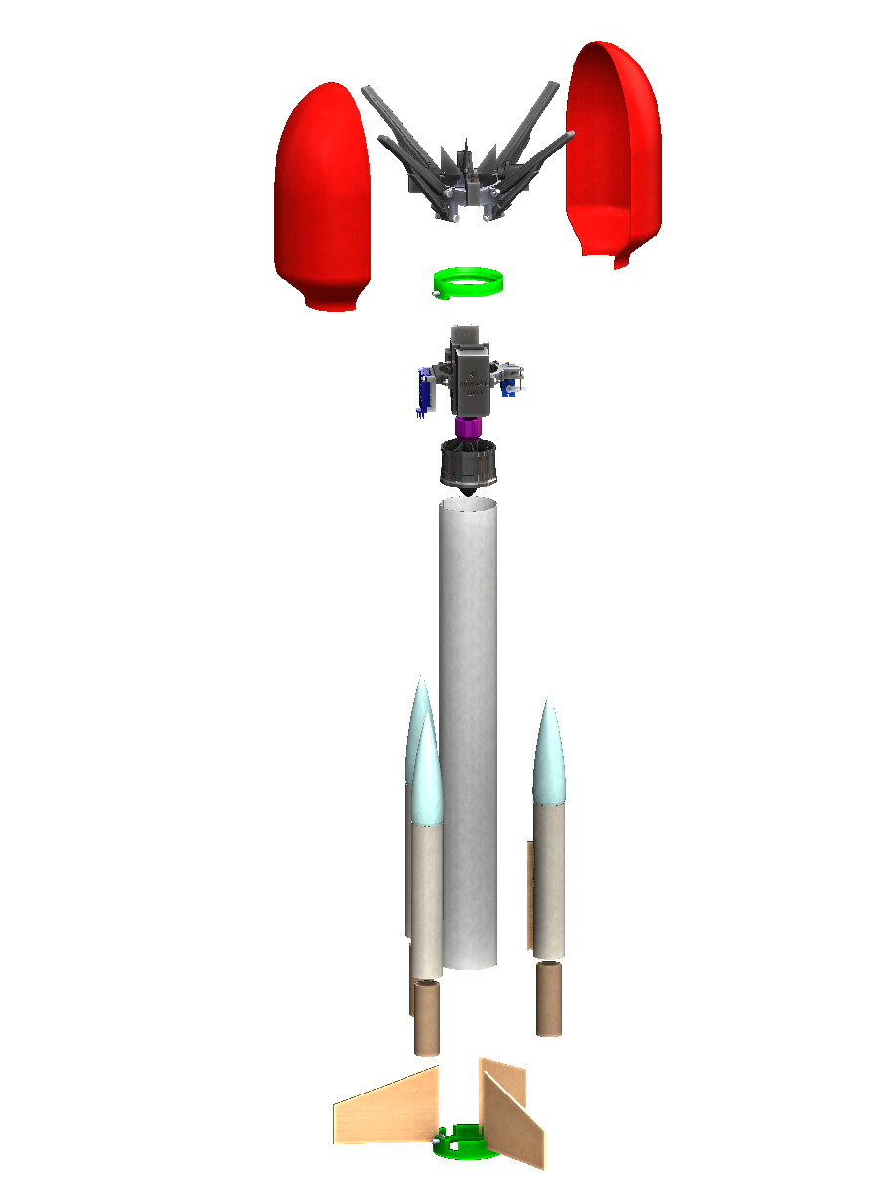

**Bibliography**

Barnard, J. (2019). *Thrust Vector Control.* Retrieved from <https://bps.space/tvc>

Grush, L. (2015, November 24). Why you shouldn’t compare Blue Origin’s rocket landing to

SpaceX. Retrieved October 21, 2019, from The Verge website:

[https://www.theverge.com/2015/11/24/9793220/blue-origin-vs-spacex-rocket-landin-jefbezos-elon-musk](https://www.theverge.com/2015/11/24/9793220/blue-origin-vs-spacex-rocket-landing-jeff-bezos-elon-musk)

Rocketry Forum. K-9 Model Rocket Landing Legs. (2019, June 30). Retrieved December

25,2019,from <https://www.rocketryforum.com/threads/k-9-model-rocket-landing-legs>.

153587/

Tuning Process Instructions: "Manual Tuning of Roll and Pitch" . (n.d.). Retrieved March 5,

2020, from https://ardupilot.org/copter/docs/tuning-process-instructions.html”